**Cover Page**

**COMPSCI 345 / SOFTENG 350 Human-Computer Interaction**

**Assignment Three: Realizing a Design**

**Student Name: Pei Chen**

**Student ID: 917698757**

**Student UPI: pche611**

____________________________________________________________________

Note: To ensure a fair playing field for all students in the class the University of Auckland will not tolerate cheating or assisting others to cheat, and views cheating in coursework as a serious academic offence.

Student Declaration:

* I declare that this work is my own work and reflects my own learning.
* I declare that where work from other sources (including sources on the world-wide web) has been used, it has been properly acknowledged and referenced.
* I understand that my assessed work may be reviewed against electronic source material using computerised detection mechanisms.

Place this page in the front as the first page of your document that you are submitting to Canvas

**Section A: Walkthrough**

The html prototype I designed is based on the problem-based learning scenario that the system needs to support a student who wants to prepare for their upcoming art history test by providing quizzes and review for the students. At the homepage the content is categorized into three subdomain **Music**, **Architecture** and **Short Quiz Challenge** section which provides the users with clear indication to fulfil their goal of preparation step by step.

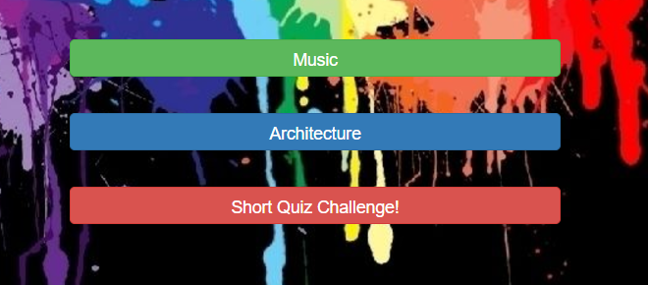

Firstly, user can systematically expand and enhance their knowledge base by clicking into either Music or Architecture section. After clicking into the studying material submain the user will be able to review categorized study material summarized base on region or biography,

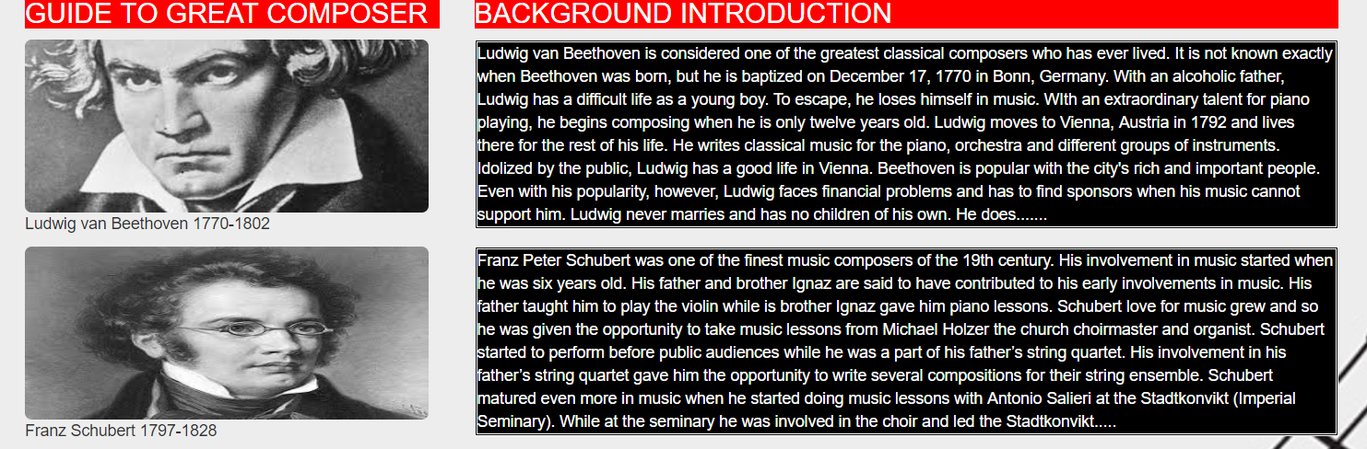

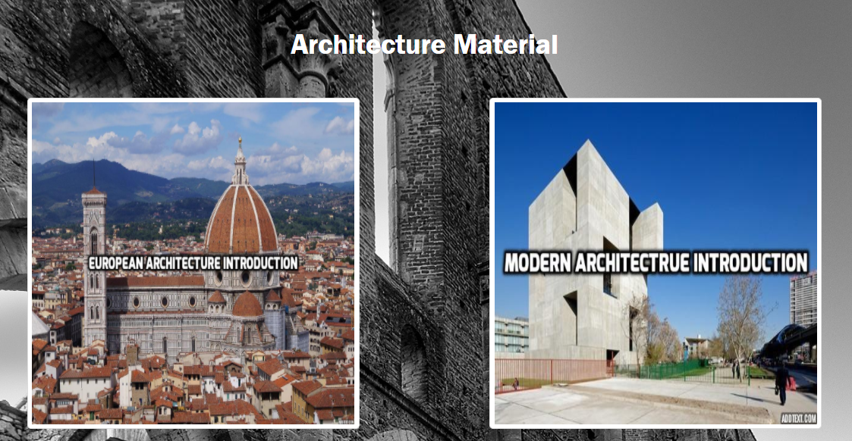

***more detailed material will be provided to the user after clicking onto the composer image or the architecture image, however these are not made functional in the prototype stage design****.* After reviewing studying material for certain amount of time the student can direct themselves back to homepage by using the **Home page** button and click into the short quiz button to do a short art quiz test to consolidate their test preparation.

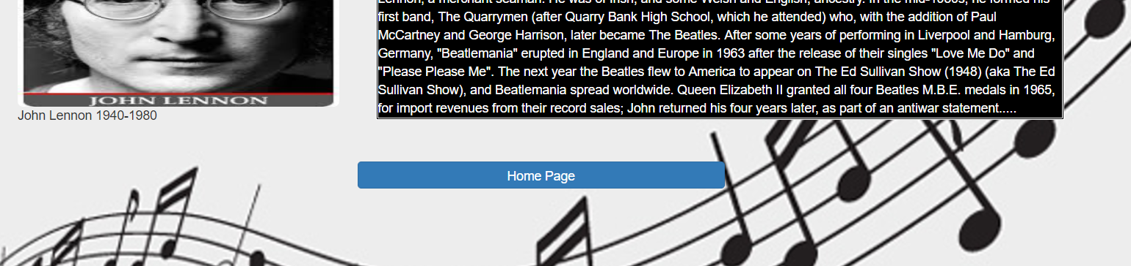

After finishing the quiz they will click **Submit and Review** button and check out their performance in the quiz and review the correct choice of the questions they did wrong.

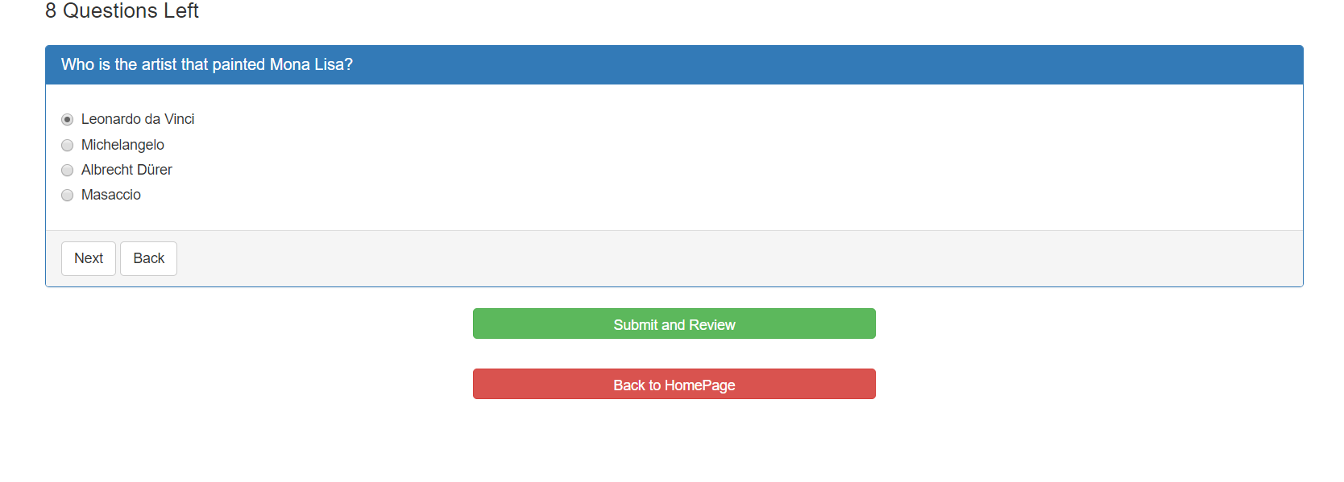

If they still think they need more material review and quiz practice they can just click **Home Page** button and redirect them back to homepage for the content they need.

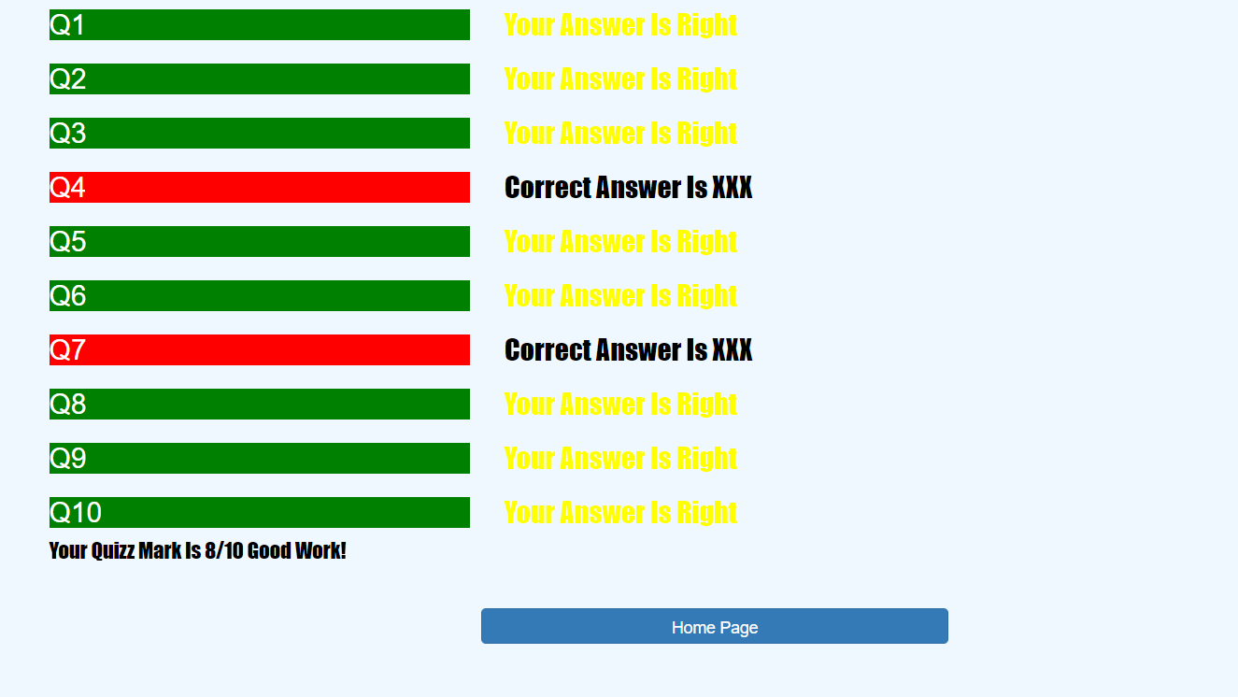

**Section B: Colour Scheme**

In this section I will talk about how I arrange colour for the various elements of the user interface. The main colour scheme I choose for the interface is mainly complementary and branding. I used lots of black-white red-green and other colour contrast in the colour design and by doing so the interface tends to be more exciting and dynamic which is in my view very good to draw attention from students as high school students tends to be young and energetic and they likes contrasted and vivid colour a lot.

Black (RGB: 0,0,0) home page background colour + white (RGB:255,255,255) text colour

Here by using very contrasted background colour and logo colour I can make the homepage theme very younger user orientated and appealing to the students that use the system.

**Section C: Borders Scheme**

For this section I will introduce how I arrange the grouping and borders of the elements of my user interface. When I design the home page I want it to be as appealing and as exciting as possible for younger users like those high school students, therefore I picked a background image with very mixed colour and very modern art style. I put three buttons horizontally down below the website title and give them same button style so by similarity principle and common fate principle they can stand out from the colourful background and be perceived all together easily as a functional section that can direct users to where they want to reach, quiz button is ordered below other button as I expect user to use it after they finish reviewing material of other sections and I made it danger theme colour in prevention of misclick as well. In the architecture page I applied proximity principle to group all material section together like an matrix since they share the same identity as a study material data base and give very clear thumbnail border to the clickable image that render the interface very clear and user-friendly. In the Music material page I arranged a material section with clickable image of specific composers and put their matching short introduction right next to the image so user can easily correlated the background material to designated composers by principle of symmetry and I added double border to large block of introduction content so they can be more distinguishable from other elements which will enhance the reading experience of users. In terms of quiz and review interface I tend to make it with simplicity principle since users want to focus more on functionality instead of appreciation when they are focusing on solving problems.

**Section D: Font Scheme**

I tend to make font choice simpler as I put most of stylish elements on colour scheme. For the digital prototype I mainly used two font families for text content which are **impact** and **normal**. I used impact font (a very stylish decorative font) on bigger size and highlighted content like homepage title and quiz review section since they are more personality-orientated and attention-grabbing than normal font. In terms of normal font I used it on most of functional and readability-orientated contents like quiz content and studying material which can enhance the reading experience of the users.

**Resource Page**

**Home page background image**

http://deskbg.com/view/495/

**Beethoven image**

http://www.classicfm.com/composers/beethoven/guides/reasons-love-beethoven/

**John Lennon image**

http://www.esquire.com/entertainment/music/news/a40292/john-lennon-esquire-profile-qa/

**Schubert image**

https://source.wustl.edu/2013/02/late-works-of-franz-schubert-feb-10/

**Architecture background**

image http://feelgrafix.com/737748-architecture-background.html

**Music background image**

https://images.template.net/wp-content/uploads/2014/11/background-music-notes.jpg